SEO Metadata
- Focus Keyword: best web design company in Kolkata
- Meta Title: Best Web Design Company in Kolkata | Off-Page SEO Strategy | Brewing Ideaz
- Meta Description: Discover how Brewing Ideaz can build online visibility as a web design company in Kolkata through local citations, quality backlinks, guest posting, and brand awareness.
- URL Slug: /off-page-seo-best-web-design-company-in-kolkata/

Secondary Keywords
- web design company in Kolkata
- website design company in Kolkata
- web design services in Kolkata
- website development company in Kolkata
- professional web designers in Kolkata
- custom website design in Kolkata
- UI/UX design company in Kolkata
- responsive web design services
- website redesign services in Kolkata
- Brewing Ideaz Kolkata

Off-Page SEO Strategy – best web design company in Kolkata
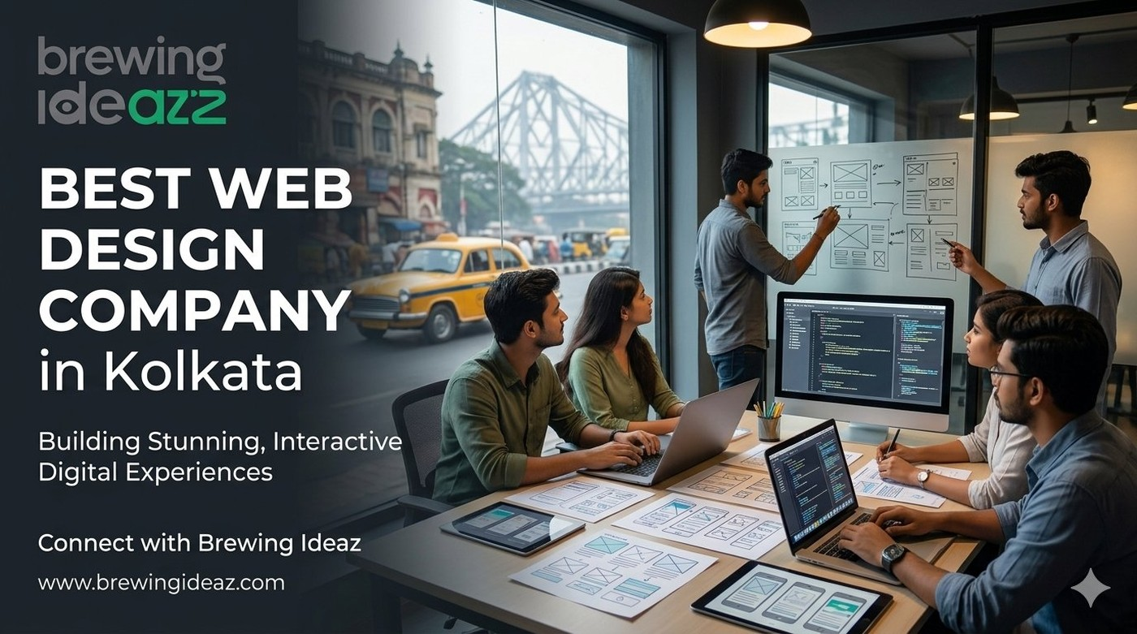
For businesses searching for the best web design company in Kolkata, a well-designed website is only one part of building a strong online presence. Off-page SEO helps improve brand discoverability, credibility, and visibility across relevant platforms.
This plan outlines the off-page SEO activities Brewing Ideaz can carry out to strengthen its presence in Kolkata — from Google Business Profile and local citations to backlinks, social engagement, and performance tracking.

1. Google Business Profile (GBP) Actions
- Weekly posts using the keyword or close variants.
- Upload website project visuals, UX/UI screenshots and team photos with Kolkata location data.
- Request reviews mentioning web design quality, usability or turnaround.
- Consistent NAP.

2. Local Citations & Directories
- Justdial, Sulekha, IndiaMART, Clutch.co, Google Business Profile, Bing Places, relevant design directories.

3. Backlink & Guest Posting Strategy
Targets: YourStory, Medium, LinkedIn Articles, design and UX blogs, local Kolkata agency lists.
Anchor Text Mix: 60% exact/close-match, 40% branded/natural.

4. Social Signals & Community Engagement
- LinkedIn, X, Reddit (r/Kolkata, r/web_design, r/indianstartups), Facebook groups.
- Optional carousel: “How to evaluate a web design partner in Kolkata.”

5. Additional Off-Page Tactics
- Website case studies that attract links.
- Local media outreach in Kolkata.
- Mention monitoring and engagement.

Tracking & Reporting
- Rankings, referral traffic, GBP insights.
Owner: [Assign name] Status: Ready after blog is live.

Book Your Consultation With Brewing Ideaz
Ready to strengthen your online presence in Kolkata? Get in touch with our team to discuss your goals.
Brewing Ideaz
Phone: (+91) 62915 47048
Email: info@brewingideaz.com
Branch Office: D-66, Bangur Avenue, Kolkata, West Bengal 700055

30 Frequently Asked Questions About Web Design Company in Kolkata
- What is off-page SEO? Off-page SEO includes activities outside a website that help improve its visibility, reputation, and authority, such as backlinks, brand mentions, reviews, and local citations.
- Why is off-page SEO important for a web design company in Kolkata? It helps potential clients discover the business through relevant websites, local listings, referrals, and brand mentions.
- What is the best off-page SEO strategy for a web design company in Kolkata? A balanced strategy includes accurate local listings, relevant backlinks, useful content distribution, genuine customer reviews, and regular performance tracking.
- How does Google Business Profile help local businesses? It helps eligible businesses display accurate information and become discoverable through Google Search and Maps.
- Which directories can a Kolkata web design company use? Businesses can consider Google Business Profile, Bing Places, Justdial, Sulekha, IndiaMART, Clutch, and relevant industry directories, depending on eligibility.
- What is a backlink? A backlink is a link from another website that directs users to your website.
- How do backlinks help SEO? Relevant, editorially earned backlinks can help search engines discover pages and may contribute to authority and relevance signals.
- What is guest posting? Guest posting involves publishing useful content on another relevant website, often with an appropriate author or business reference.
- Where can a web design company publish guest articles? Agencies can explore relevant industry publications, startup websites, business blogs, and industry websites that accept useful contributions.
- What is anchor text? Anchor text is the clickable text in a hyperlink that describes or identifies the linked page.
- What anchor text should a web design company use? Use natural, descriptive, and branded anchor text rather than repeatedly forcing exact-match keywords into links.
- How important are social media shares for SEO? Social media shares can increase content exposure and attract visits or mentions, but they do not guarantee improved search rankings.
- Which social media platforms can a web design company use? LinkedIn, X, Facebook, and relevant online communities can help distribute content and connect with potential clients.
- How can a business get genuine client reviews? Ask clients politely for honest feedback after completing a project and follow the relevant platform’s review policies.
- What is NAP consistency in local SEO? NAP stands for Name, Address, and Phone number. Consistency helps customers and platforms identify the same business across listings.
- Can off-page SEO work without paid advertisements? Yes. Off-page SEO can focus on organic activities such as earning relevant backlinks, maintaining business listings, and sharing useful content.
- How long does off-page SEO take to show results? The timeline varies depending on competition, website history, implementation quality, and other factors. Results are not guaranteed within a specific period.
- What role does content play in off-page SEO? Useful content gives other websites and audiences a reason to reference, share, or discuss the business.
- Should blog images include the company logo? A relevant branded image can support brand recognition. The logo should be clear, and the image should match the article’s topic.
- How can off-page SEO performance be tracked? Google Search Console, analytics reports, business listing insights, and backlink monitoring tools can help track performance.
- Is off-page SEO only about backlinks? No. It can also include local citations, reviews, brand mentions, digital PR, and content outreach.
- Can local SEO be part of off-page SEO? Yes. Local listings, citations, and customer reviews are commonly included in local off-page SEO activities.
- How should a business choose guest-posting websites? Look for topical relevance, a genuine audience, editorial standards, and website credibility. Avoid link schemes.
- What is digital PR in SEO? Digital PR involves earning media coverage and brand mentions by sharing useful stories, research, expert insights, or resources with relevant publishers.
- How can brand awareness support SEO? Brand awareness may lead to more branded searches, website visits, mentions, and links, although results vary.
- Which tools are useful for off-page SEO? Google Search Console, analytics tools, backlink analysis platforms, and Google Business Profile insights can help monitor different aspects of performance.
- Do online reviews directly improve search rankings? Reviews can influence customer trust and local visibility, but rankings depend on multiple factors and are not guaranteed.
- What is a case study in web design? A web design case study explains a project’s objectives, strategy, execution, and verified outcomes.
- Can a Kolkata web design company get featured in local publications? Yes. An agency can pitch relevant stories, expertise, or project insights to local publications and business communities, though coverage is not guaranteed.
- How can I contact Brewing Ideaz for web design services in Kolkata? You can contact Brewing Ideaz by calling or WhatsApping +91 62915 47048 or emailing info@brewingideaz.com to discuss your web design requirements.

